**HOW TO LOGIN TO BODS**

GOTO START<-SELECT SAP DATASERVICES 4.2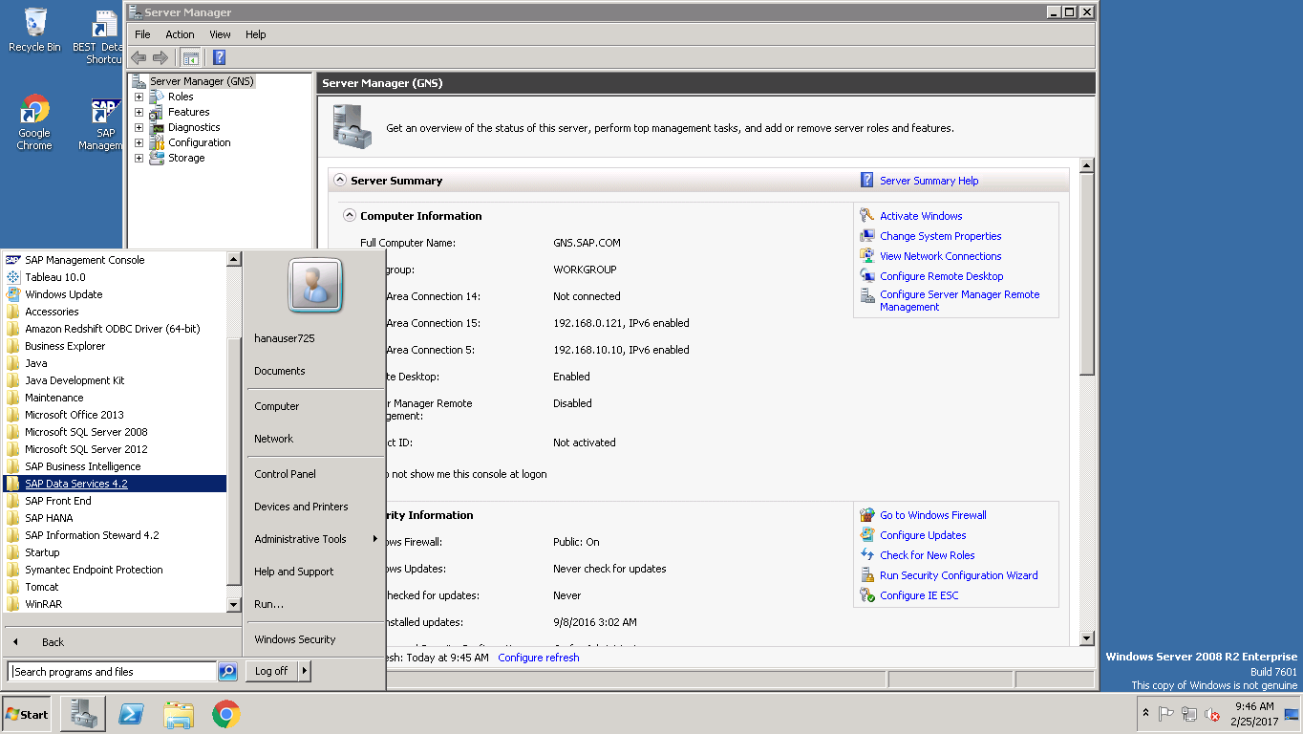 EXPAND DATA SERVICES <-SELECT DATASERVICES WORKBENCH AND CLICK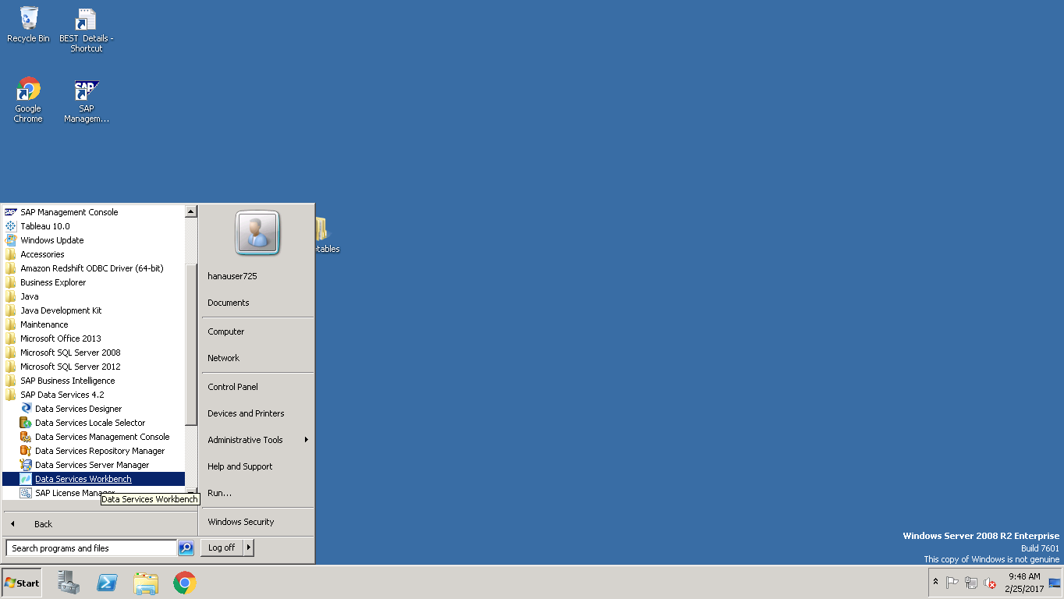 SYSTEM:GNS:6400

USERNAME:BEST

PASSWORD:Welcome123

<-CLICK LOGON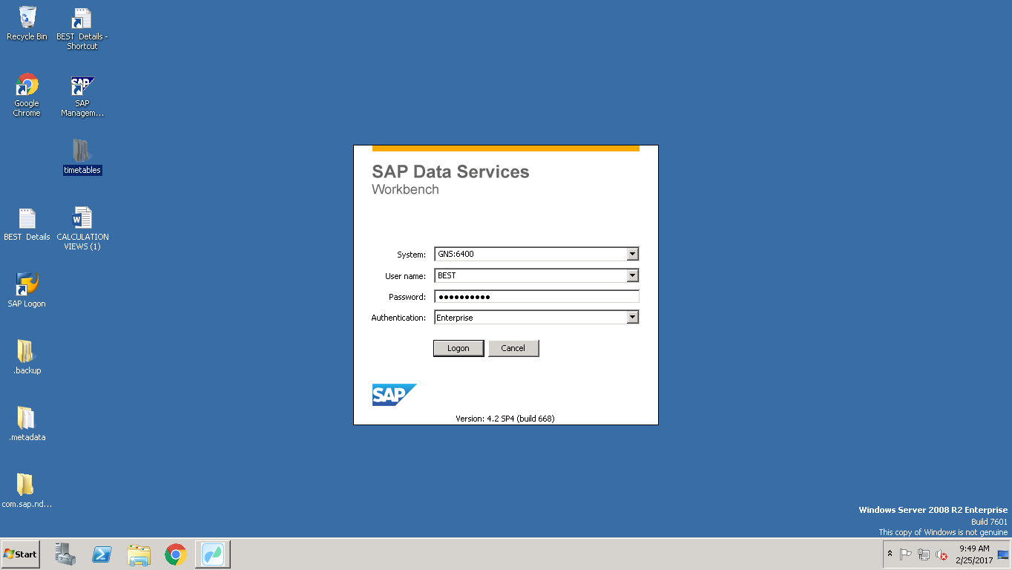 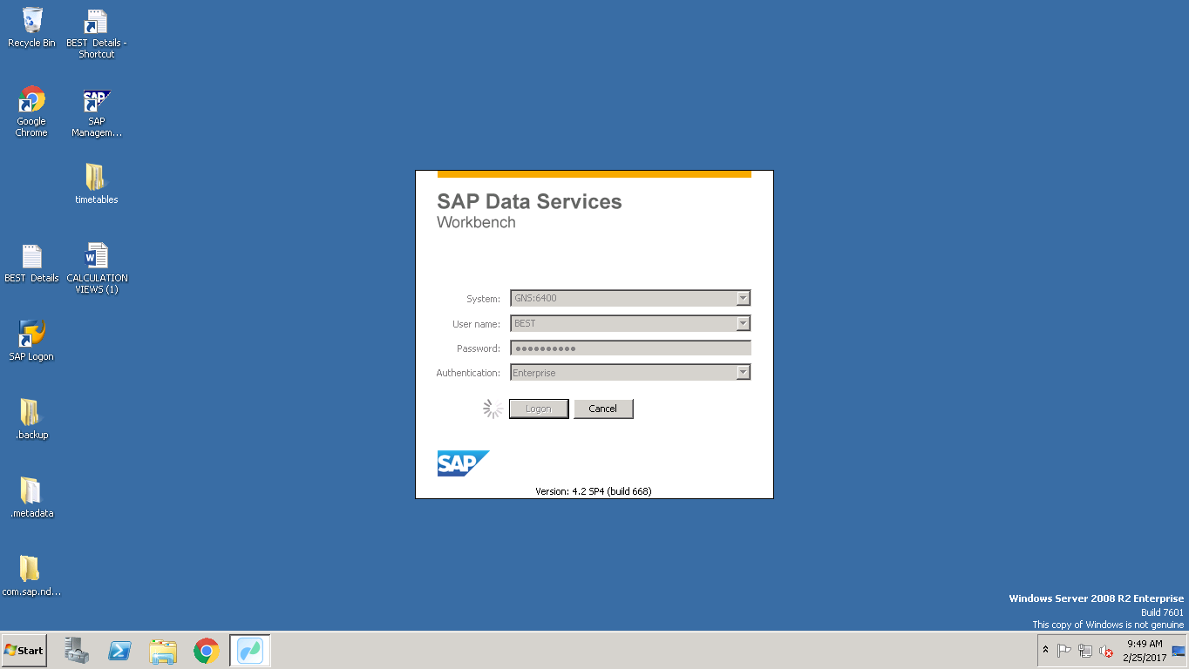

DATA SERVICES WORKBENCH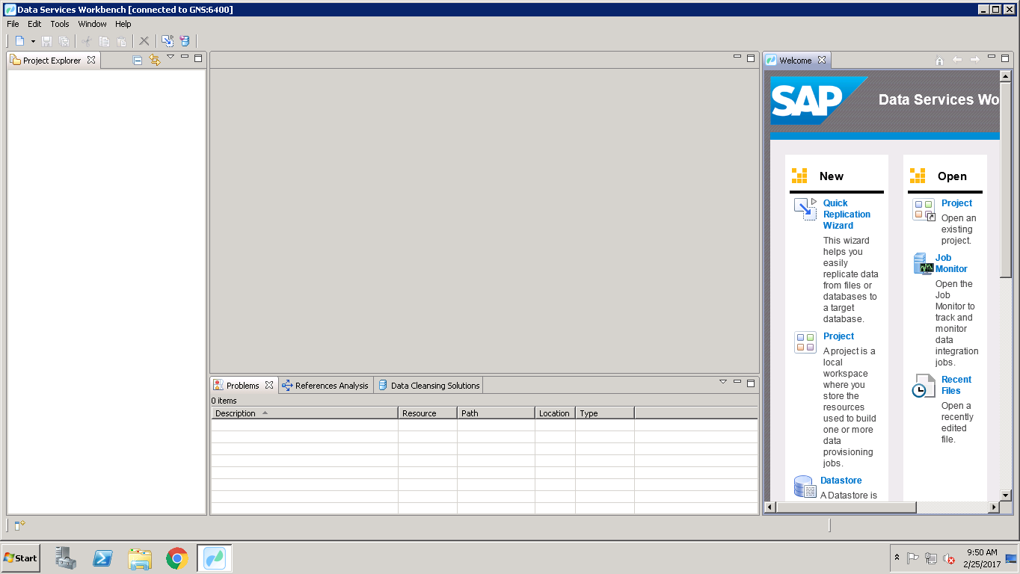

**LOGIN TO REPOSITORY**

GO TO START<-CLICK ALL PROGRAM<-SELECT DATA SERVICES 4.2 AND EXPAND<-CLICK DATA SERVICES REPOSITORY MANAGER <-CLICK YES 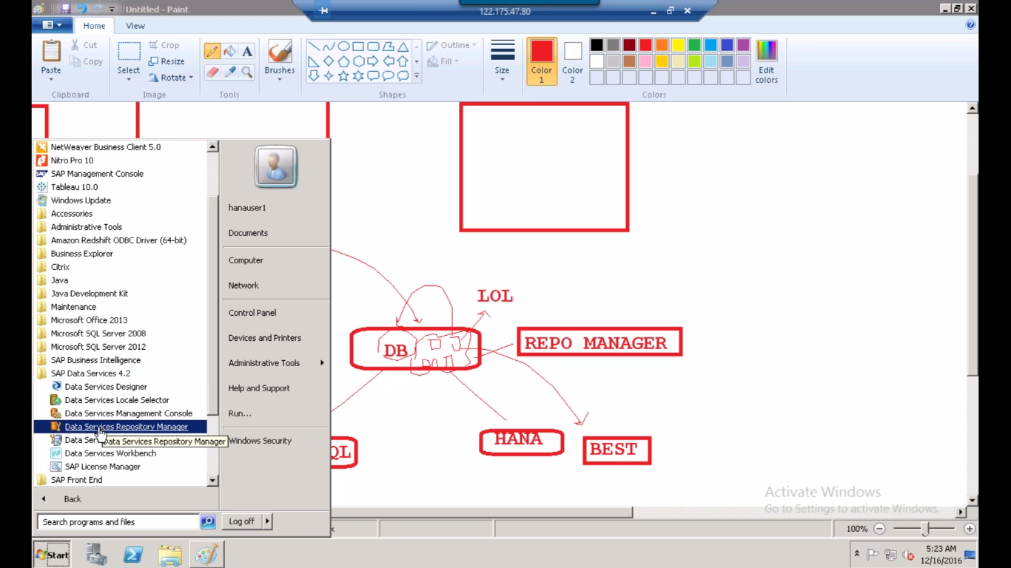 ENTER DETAILS DATABASE TYPE, USERNAME: BEST, PASSWORD: Welcome123<-CLICK CREATE<-CLICK YES 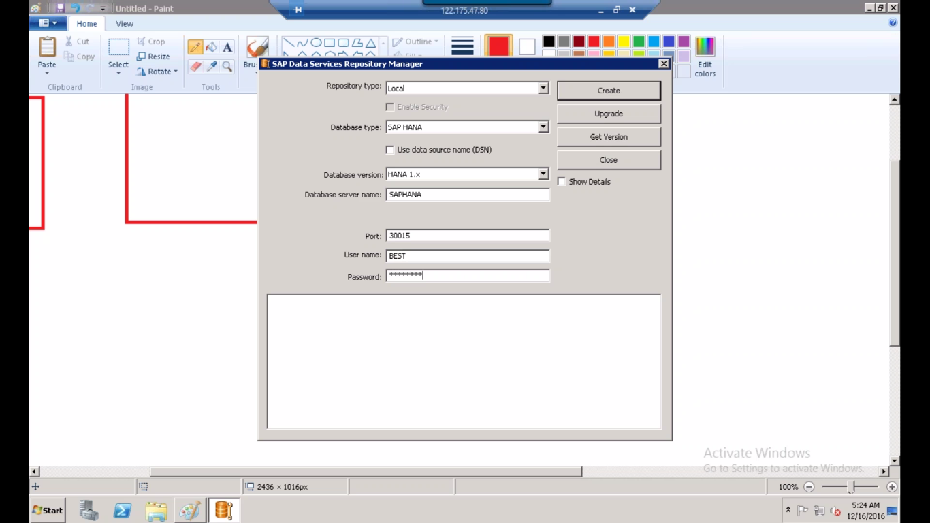 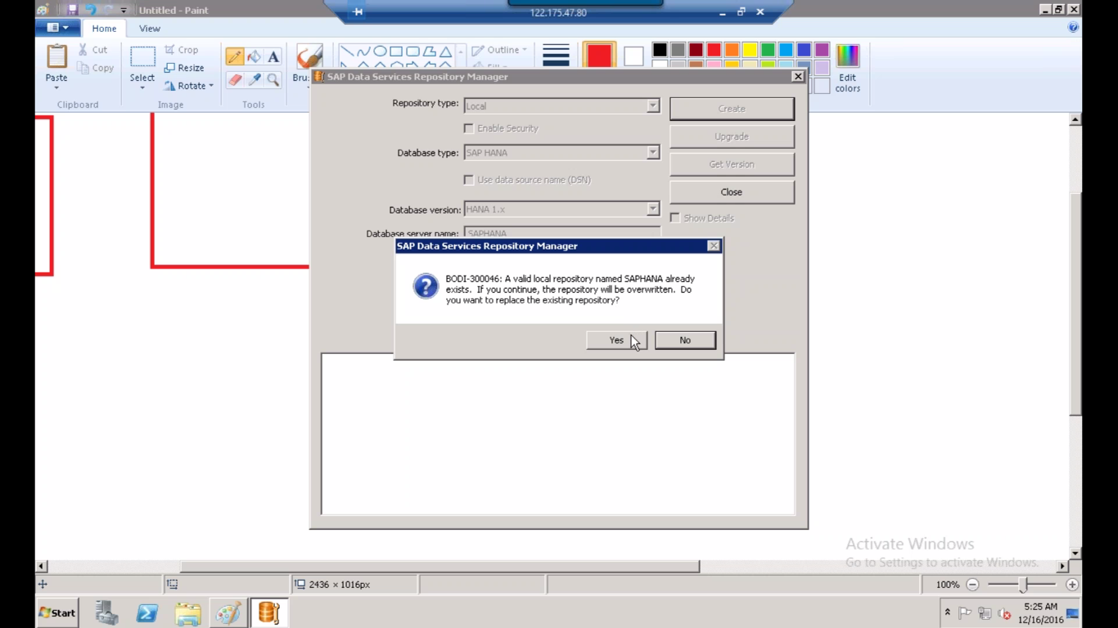

**JOBSERVER:**

GO TO START<-CLICK ALL PROGRAM<-SELECT DATA SERVICES 4.2 AND EXPAND<-CLICK DATA SERVICES SERVER MANAGER <-CLICK YES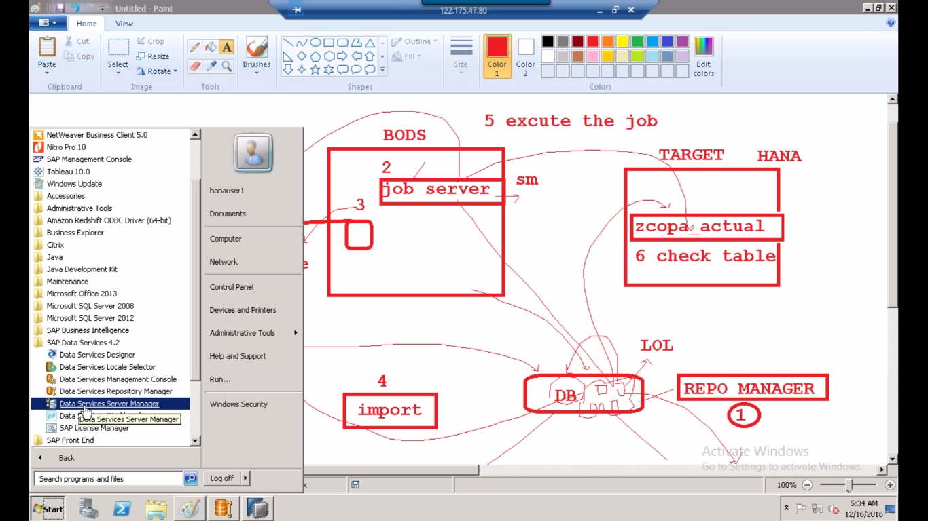

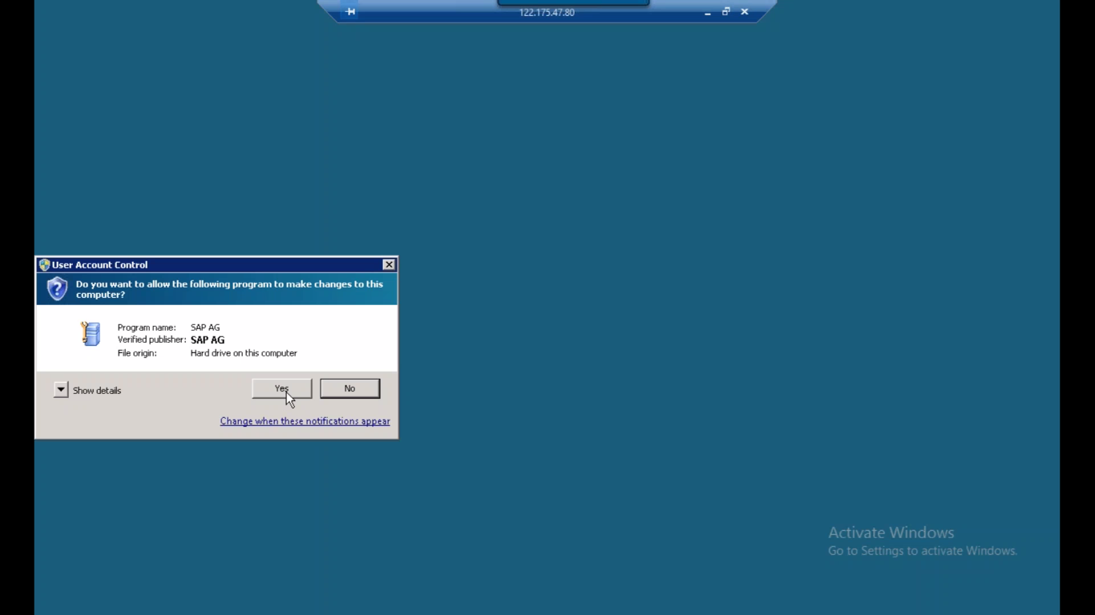CLCIK CONFIGURATION EDITOR<-CLICK ON ADD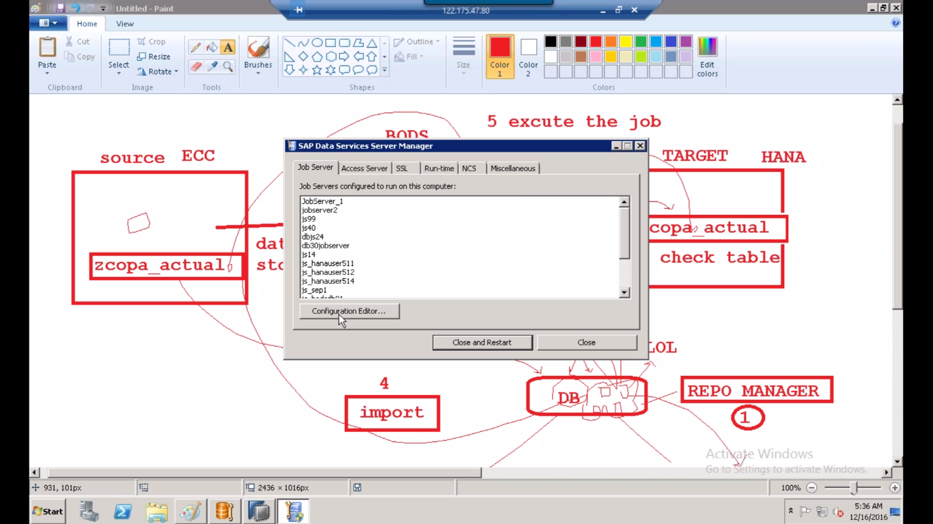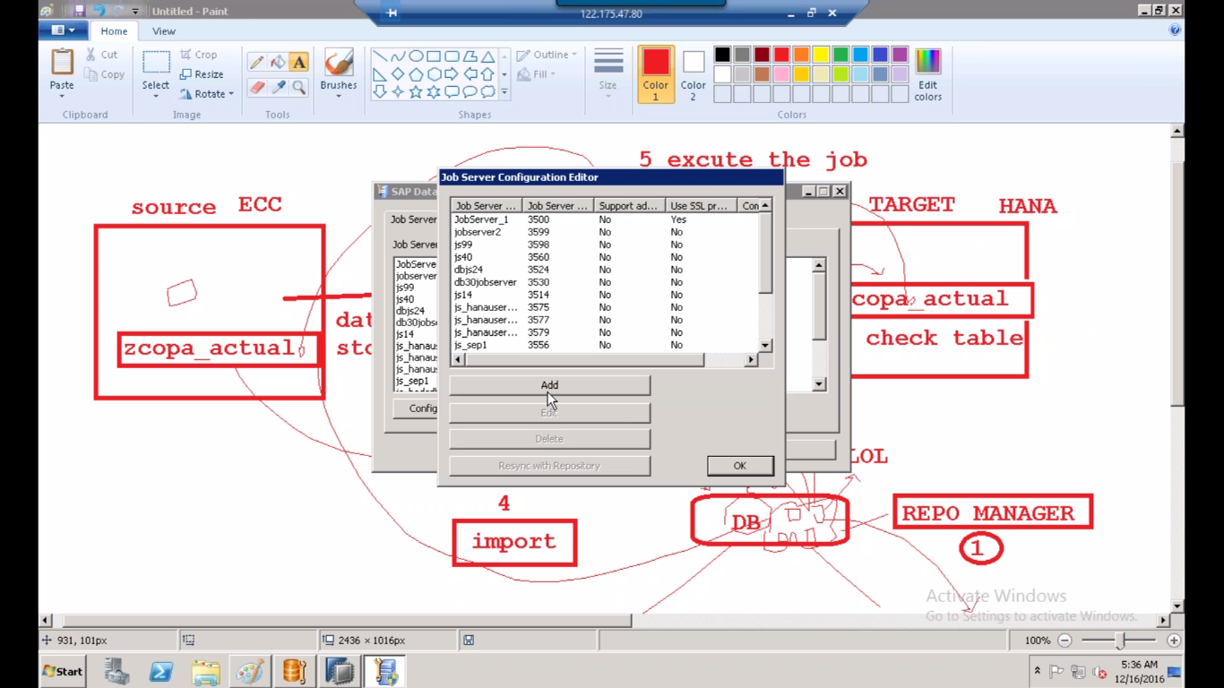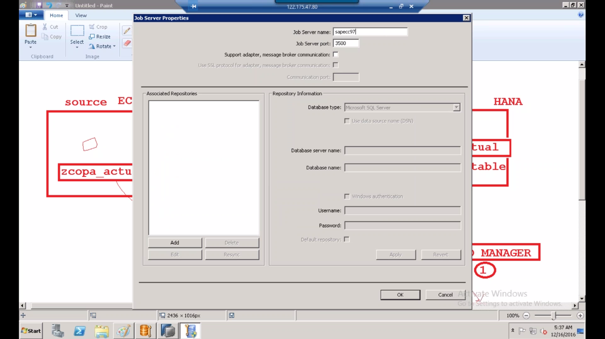JOB SERVER PORT WILL SUPPORTS FROM 3500 TO 9999 YOU CAN SELECT ANY PORT NUMBER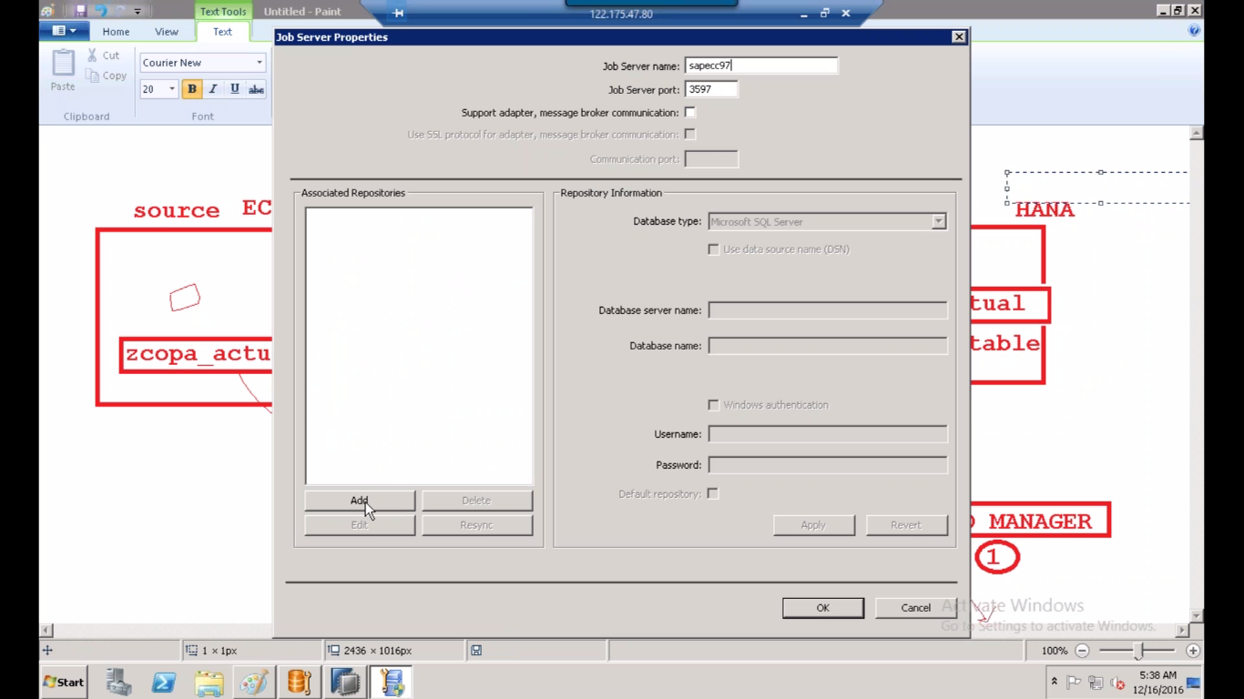SELECT DATABASE TYPE AS SAPHANA <-CLICK APPLY<-CLICK OK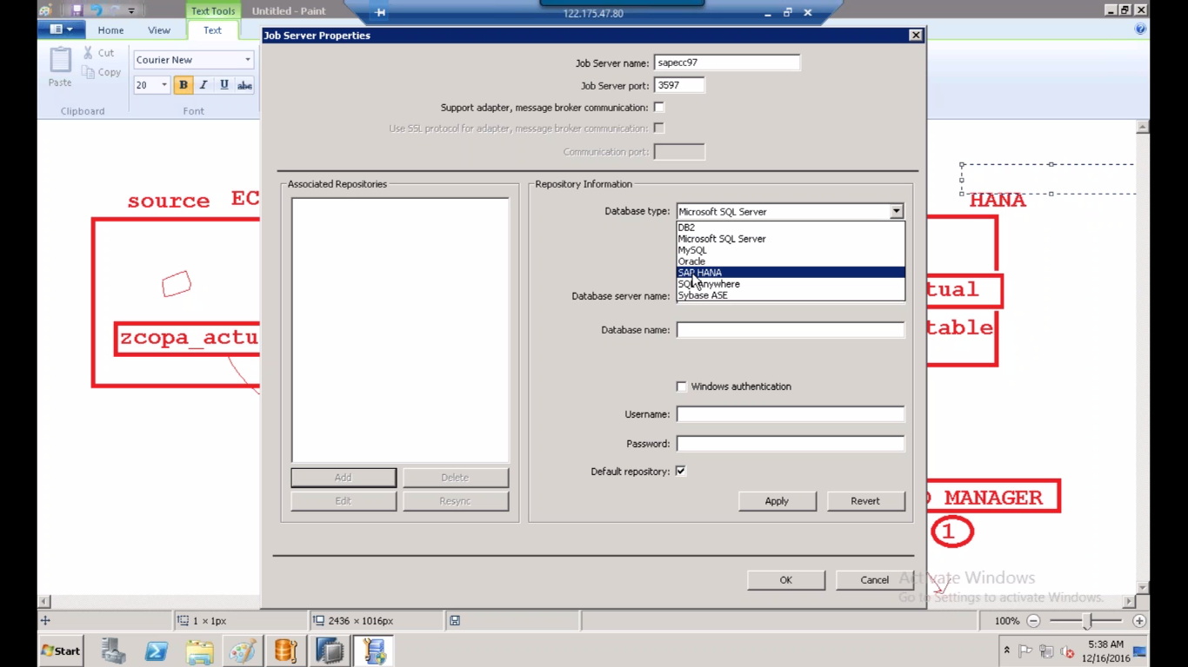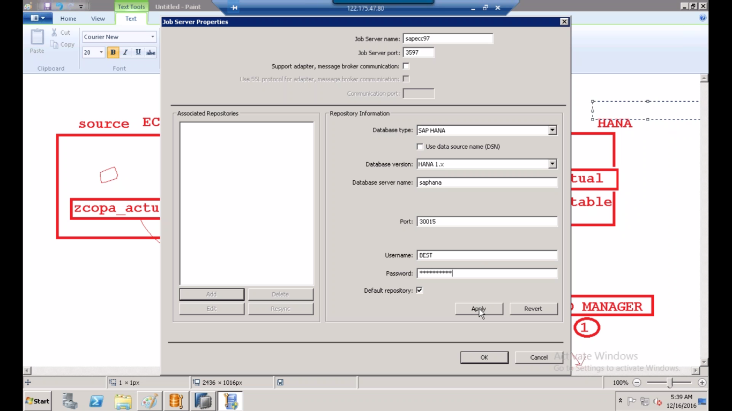HERE ONE REPOSITORY IS CREATED<-CLICK OK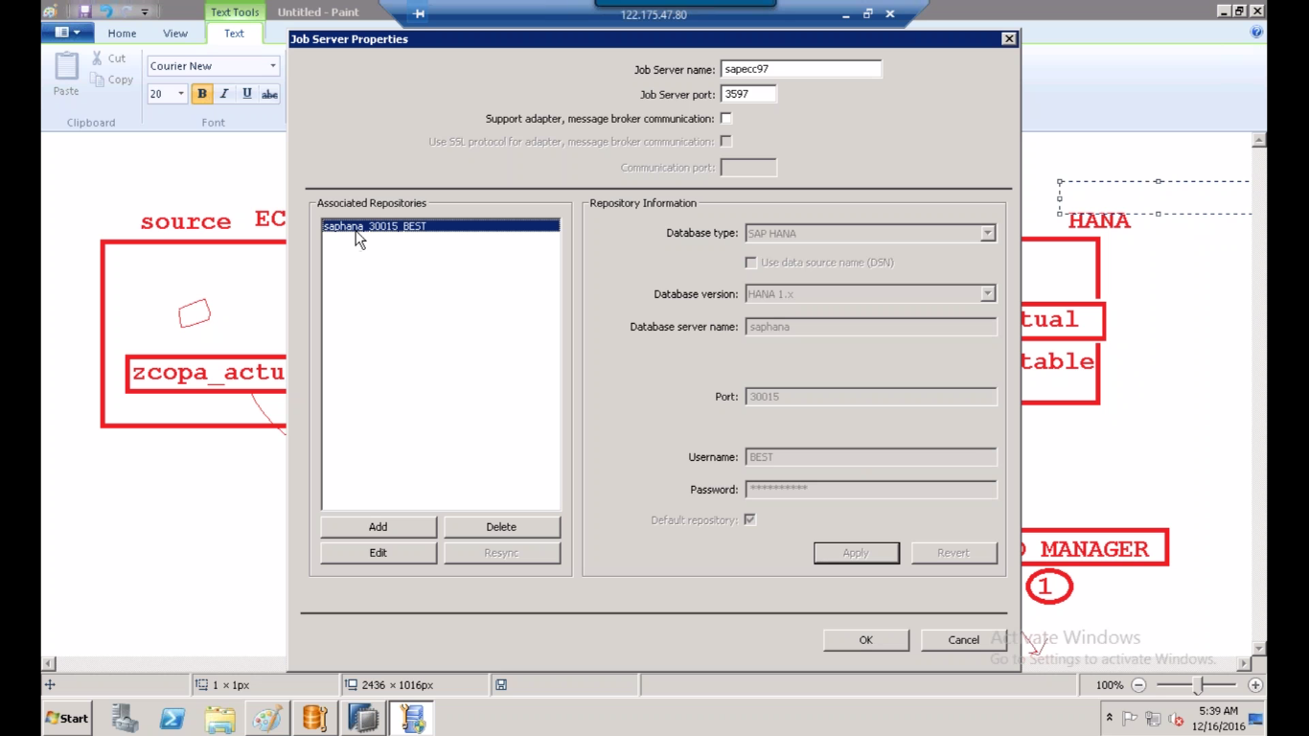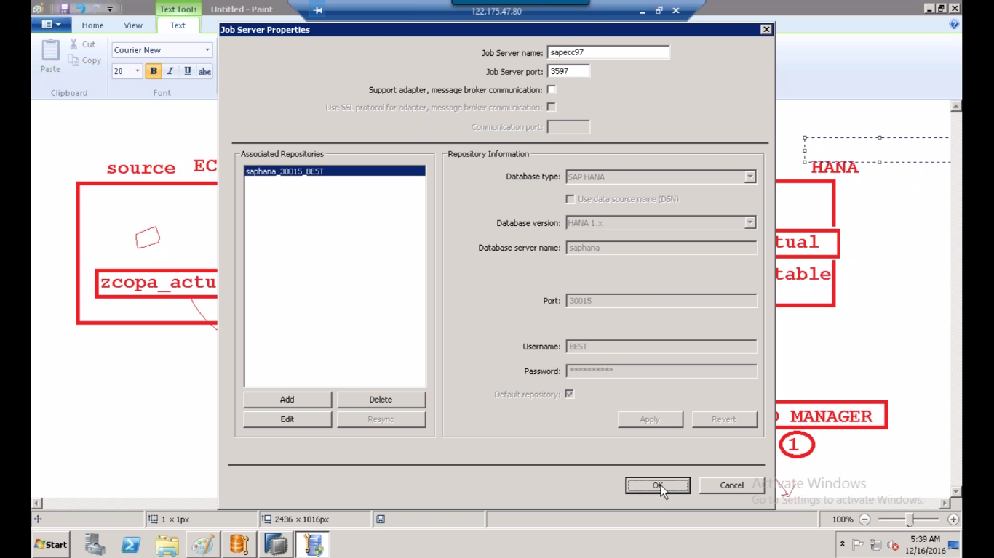SELECT SAPECC97 <-CLICK OK<-CLICK ON CLOSE AND RESTART<-NEXT CLICK OK